**30.AWS-CloudWatch & Custom-Metrics**

**AWS-CloudWatch**

Cloud watch is nothing but a monitoring

By default, AWS cloud watch will monitor all AWS Services

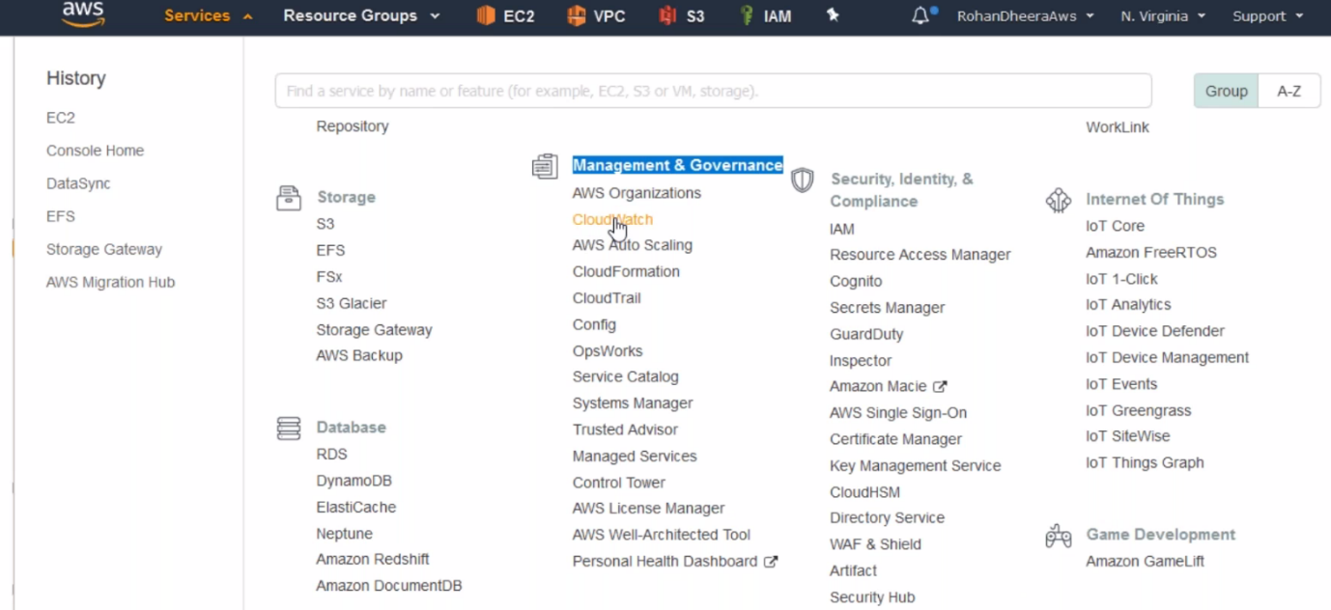

**Dashboard**

you want to know, what happened in the monitoring

you want to know the details of last 6 months billing. You can create dash board to monitoring the billing. This is for management use.

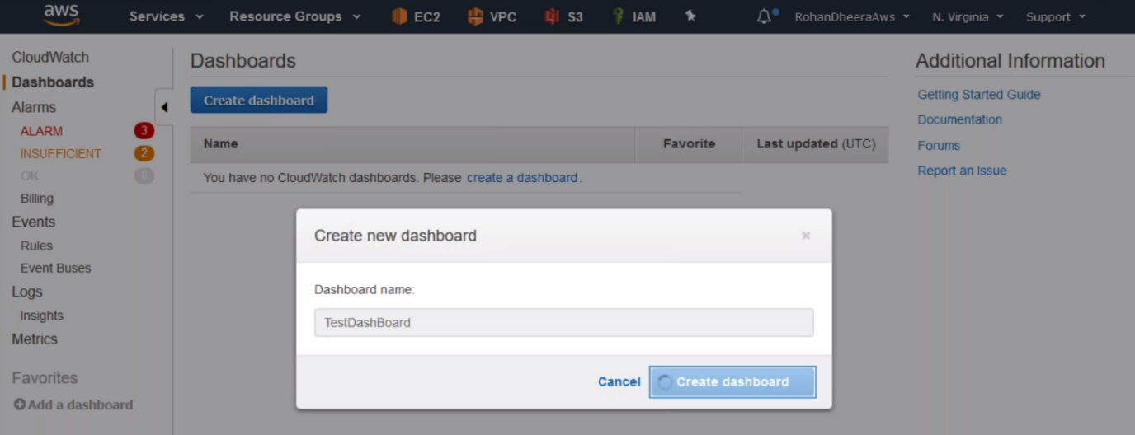

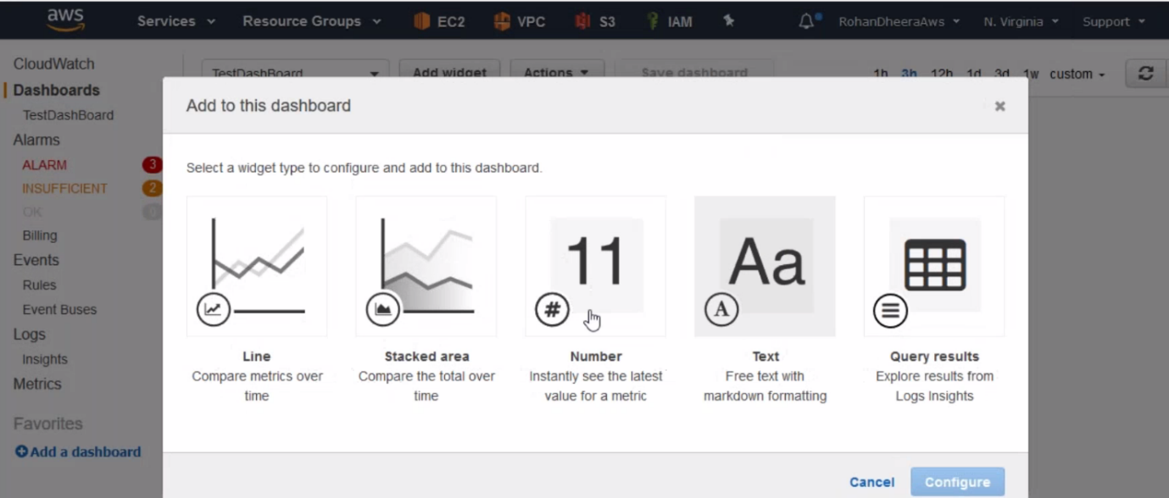

--- for Eg billing graph. I want to know billing details of last 6 months.

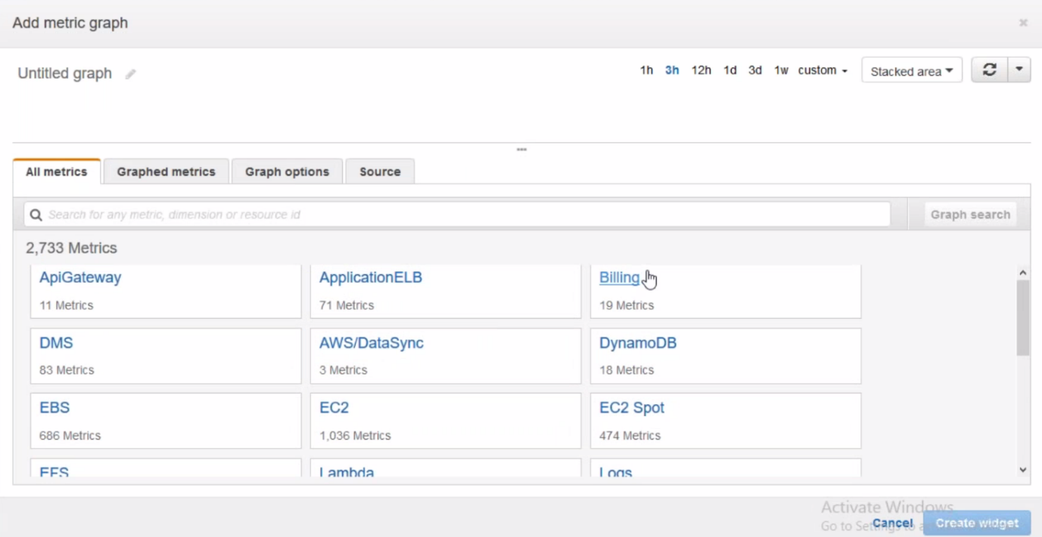

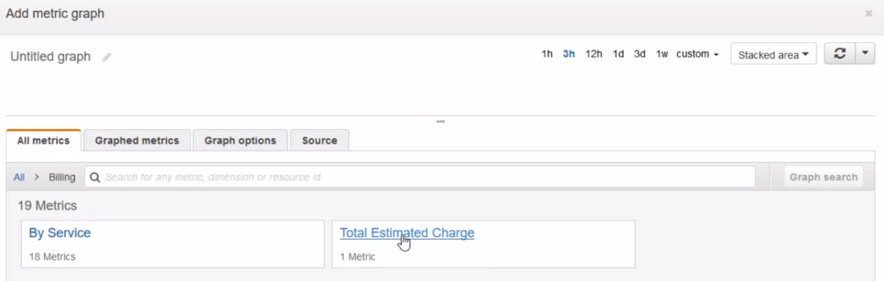

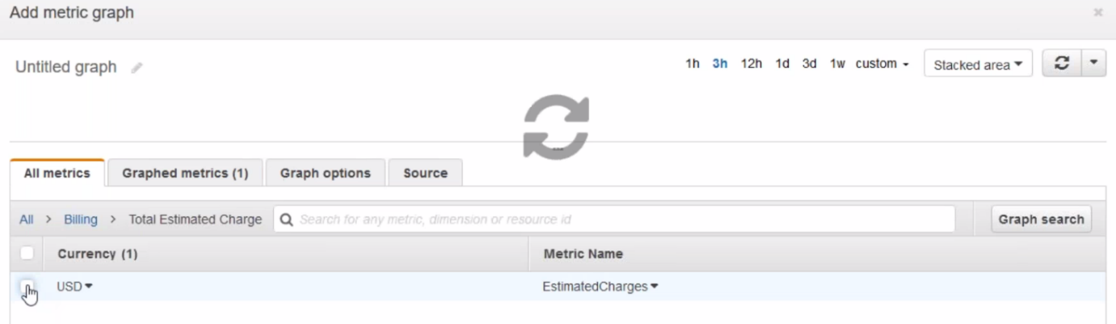

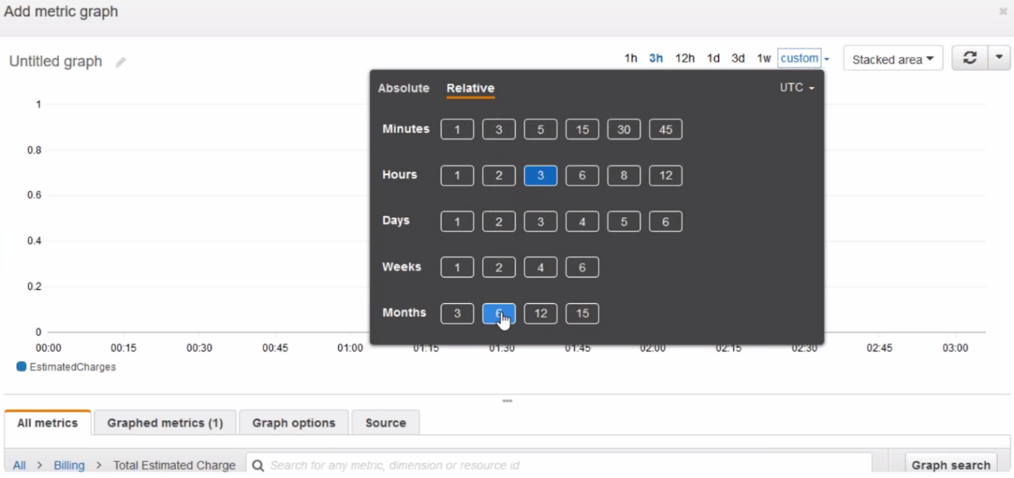

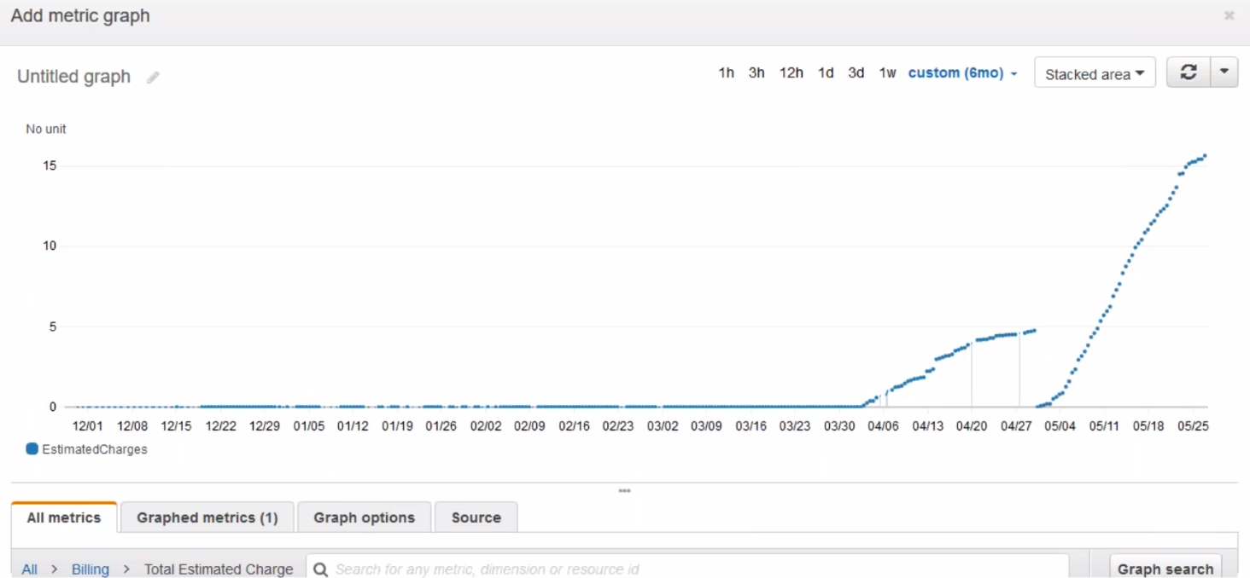

--- click on widget

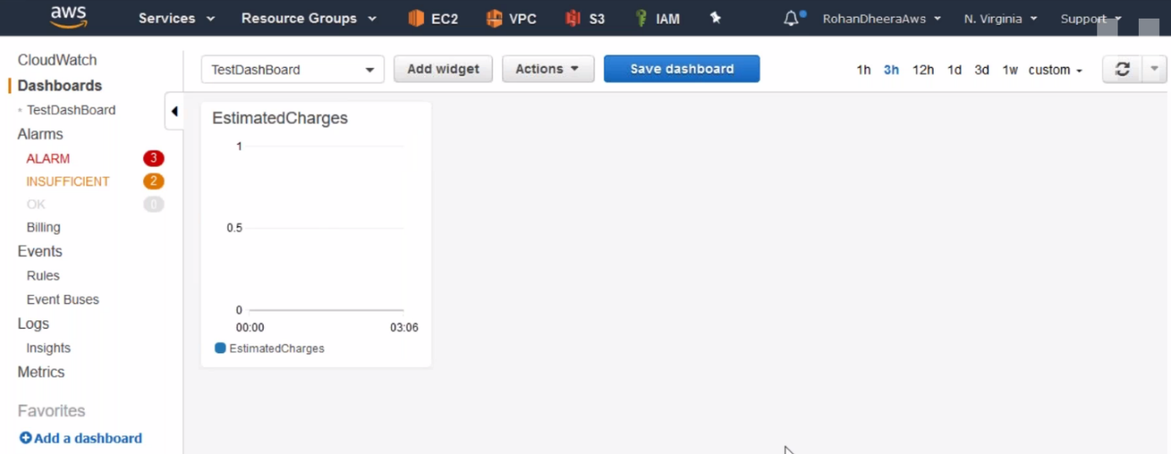

**ALARAM**

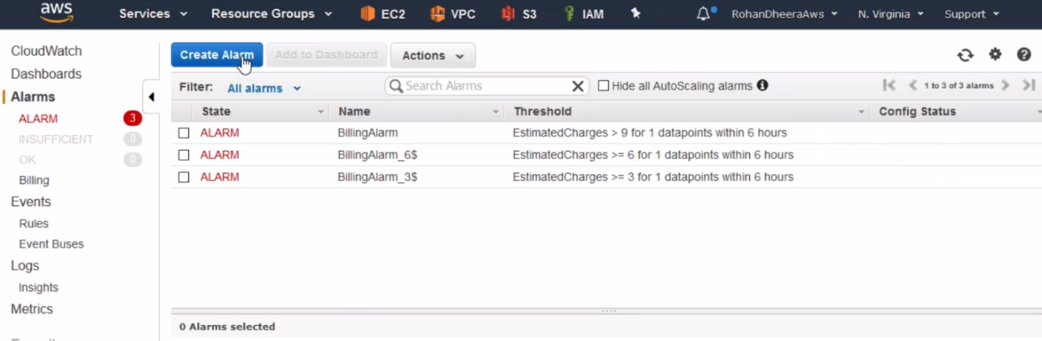

--- Click on create alarm

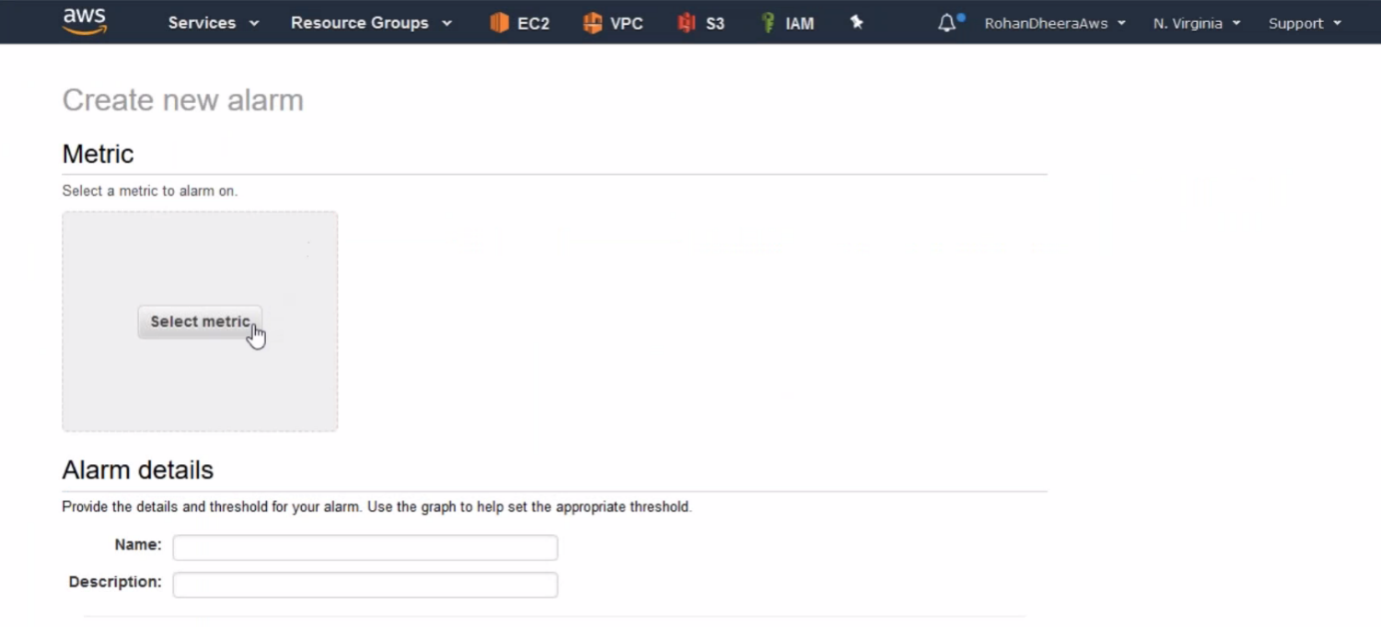

--- click on select metric’s

--- in EC2 the memory is cannot be monitored, you want to monitor the memory then you need to install the 3rd party tool

**Simple notification service**

You want to get notified when your CPU utilization is reaches maximum or your billing reaches maximum…etc in this kind of situation we use simple notification service. This feature alerting us by sending us emails, messages, calls…etc

Even we can use 3rd party tools like pager duty, data dog….etc

**topics**

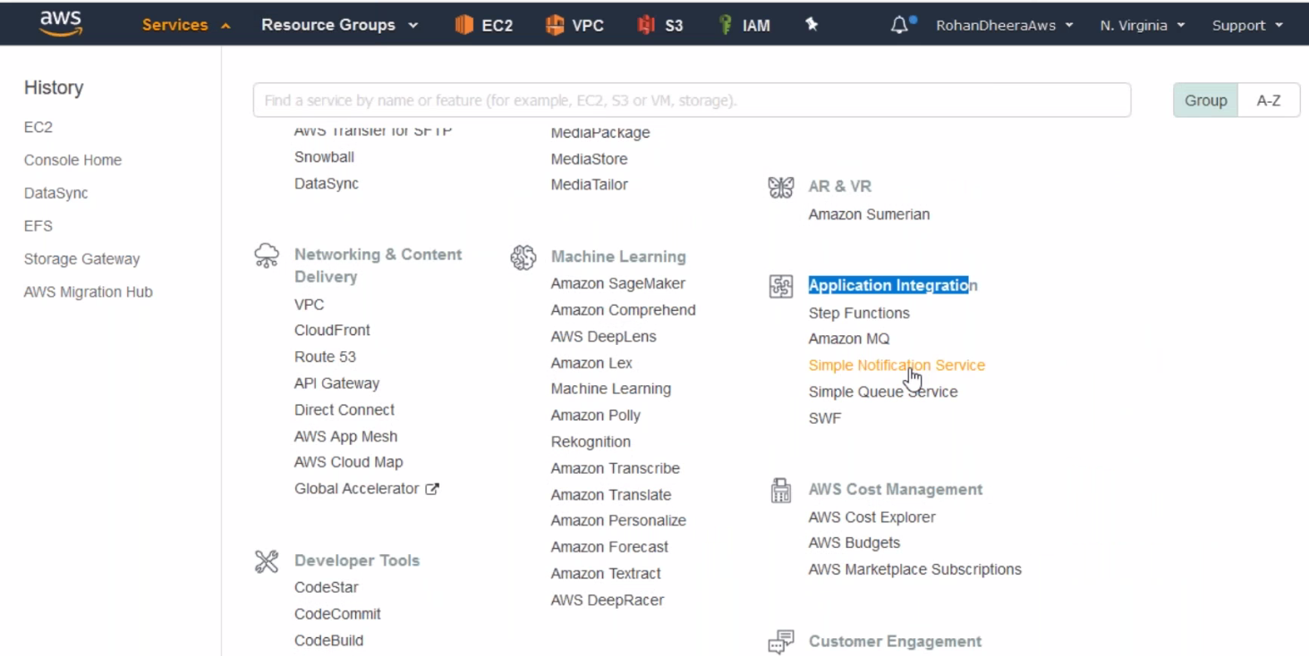

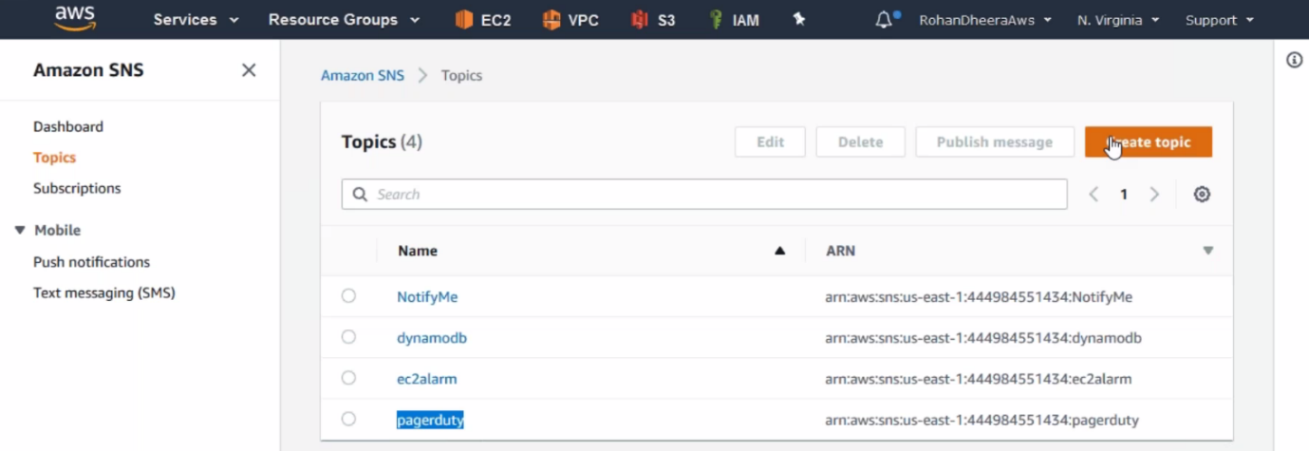

--- click on create topic.

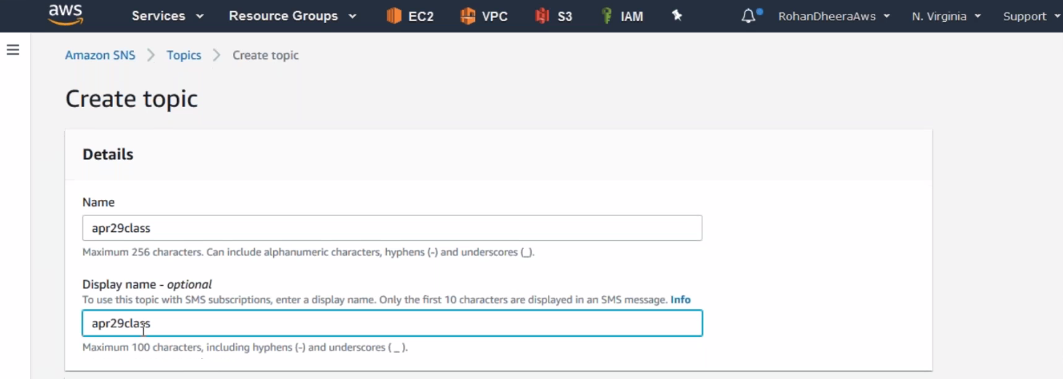

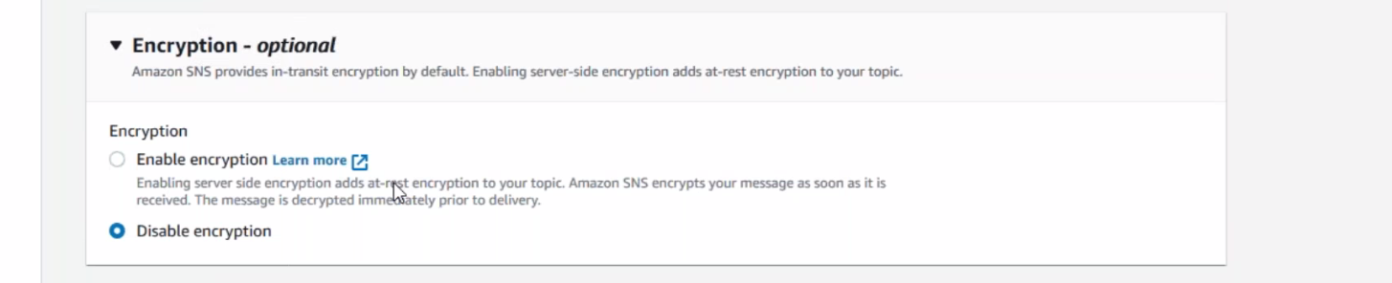

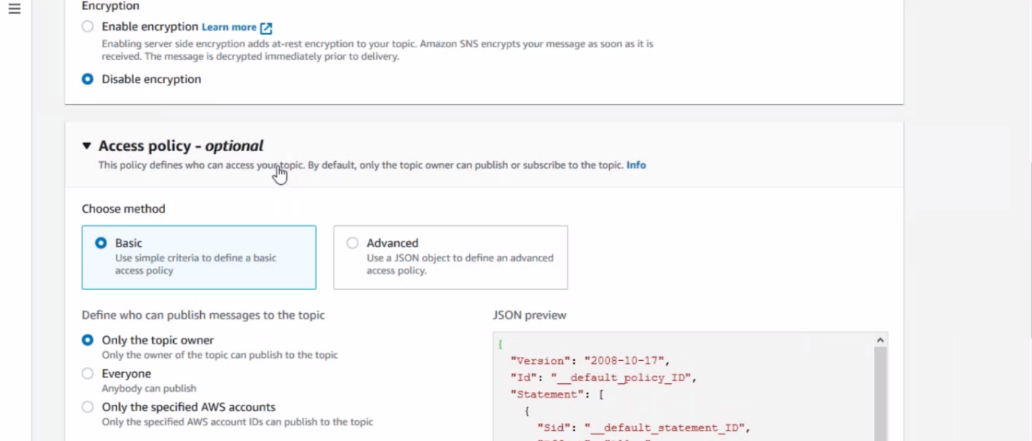

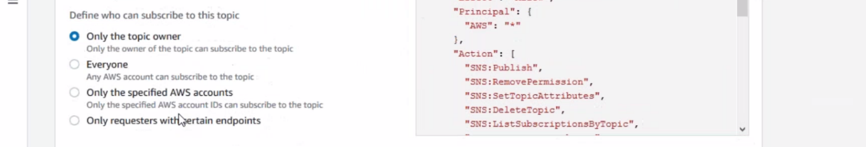

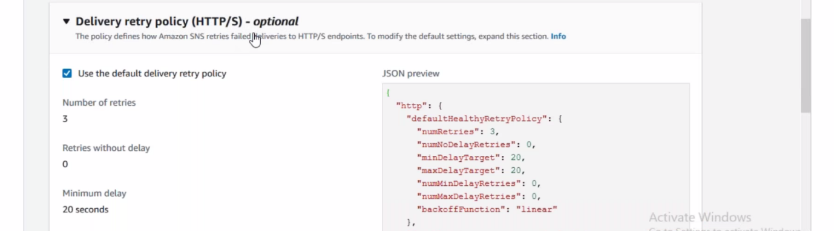

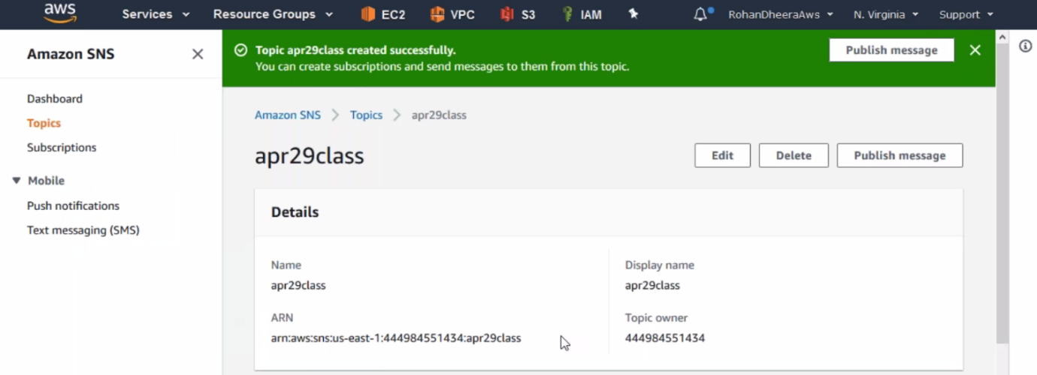

--- topic is created now, we need to create subscription for topic.

**Subscriptions**

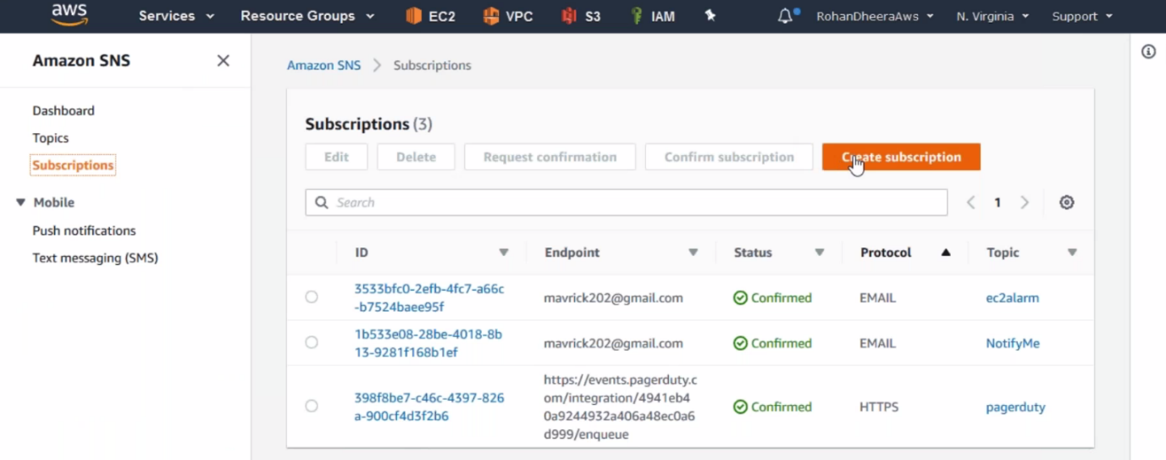

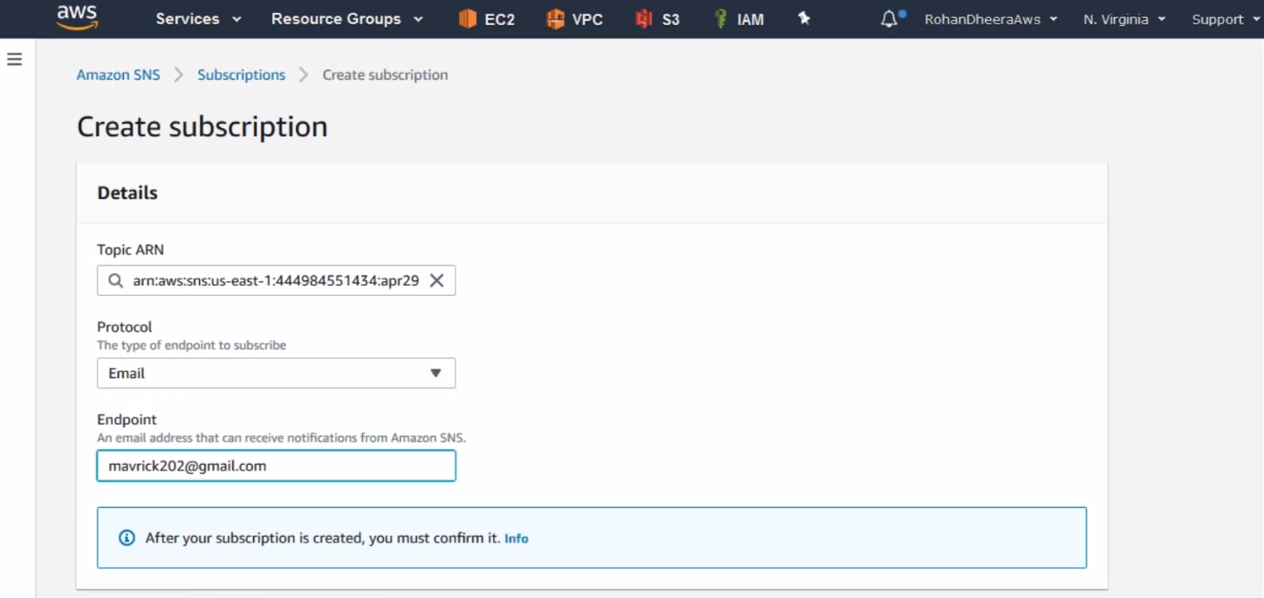

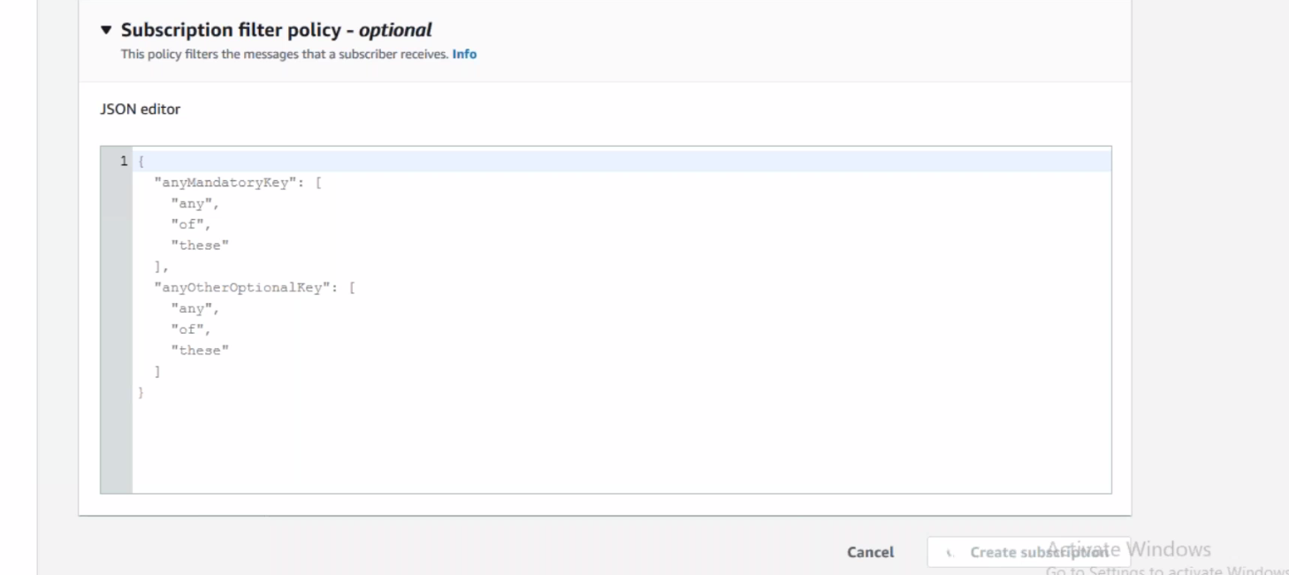

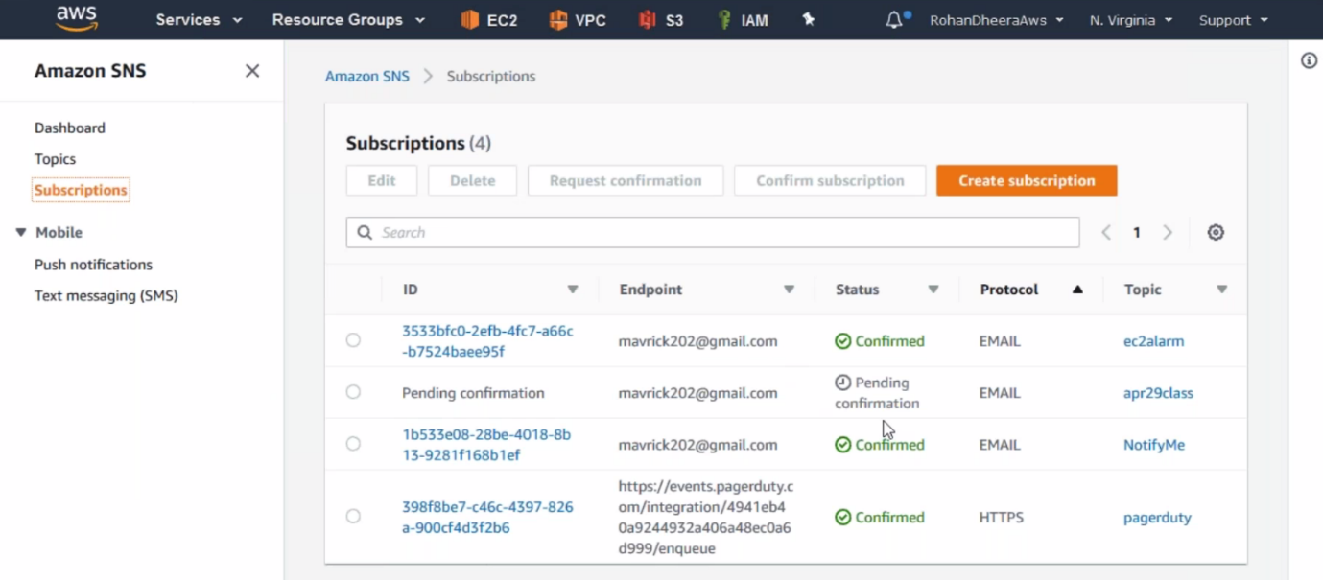

--- this subscription pending, we need to go to Gmail and confirm it.